Nicholas Garrett
Dr. Zibran
CS 4416
10/30/2021

Homework 1: Excercise on Code Injection Through Buffer Overflow

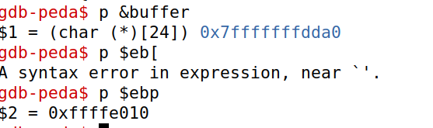
I followed all the steps and did my best to not make any mistakes. However, for whatever reason, something seems wrong with my system. For whatever reason, my pointers to buffer and ebp were nowhere close to each other.
I ran the code to prevent kernel pointer randomization and used the codes to do things just like in your video presentation—then again using the exact scripts from the SEED website for this exercise, then again using a “solved” solution I found online. The terminal commands were all the same, but I wanted to make sure there was no problem with mistyping on my end.
I will explain my process as best I can—despite it still ending in failure—to (hopefully) show that I understand the principle intended to be applied.

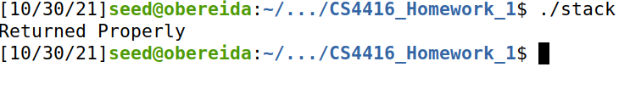
First, I ran the “sudo sysctl -w kernel.randomize_va_space=0” command and configured the /bin/sh pointer. Then compiled and ran stack.c to ensure it was operating correctly.

Next, I added badfile (with placeholder text of “hello there”) using the “touch badfile” and “nano badfile” commands.
Third, I compiled stack.c using GDB debugger, and found the address of the buffer and ebp:

Then, since the return address is at <ebp>+4 bytes, I set the return address to point to where the str buffer should have started:
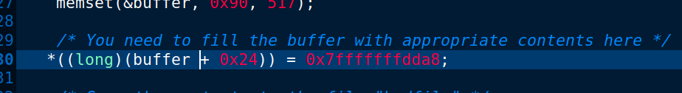
And added into exploit.c to copy the shellcode into buffer: “memcpy(buffer+sizeof(buffer)-sizeof(shellcode),shellcode,sizeof(shellcode));”.

Finally, I compiled exploit.c, ran it, and then ran stack.c.

* I am still trying to get it to work, so if you see this message at the bottom of my submission, then obviously I did not get it to work in time to re-submit it.

